1.Installing KubeCtl in the Ec2 Instance:(Tool to manage kubernetes cluster)
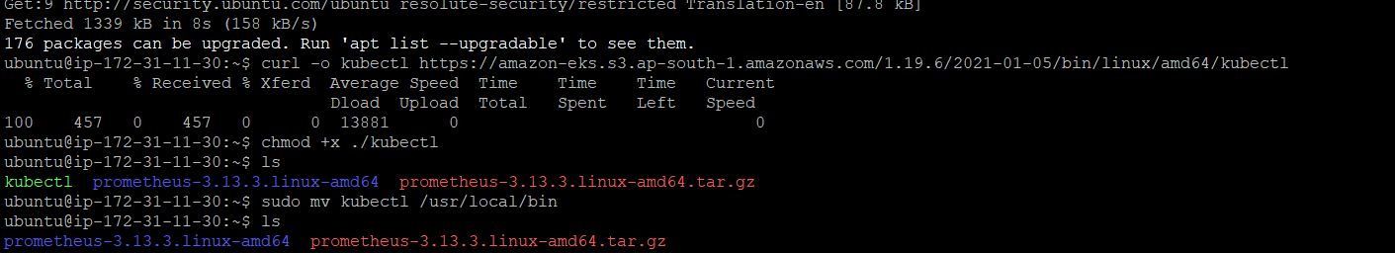
2.Installing Eksctl in the Ec2 instance:(Tool To create Kubernetes cluster in AWS)
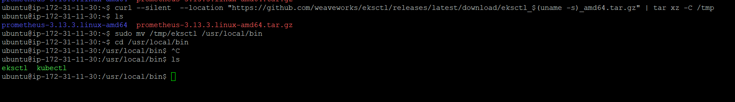
3.Creating cluster in Ec2 Machine:

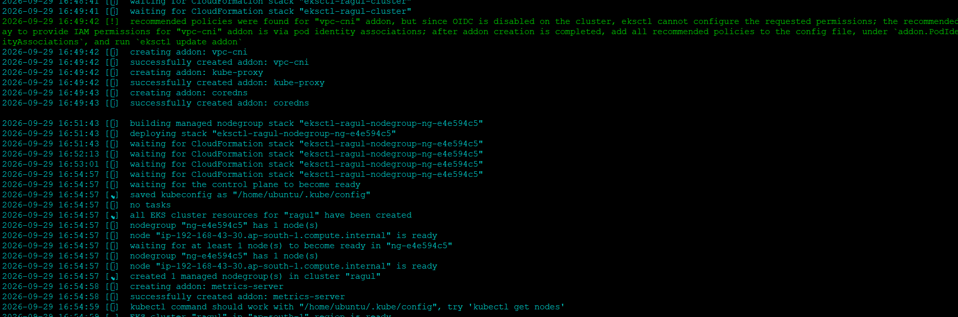
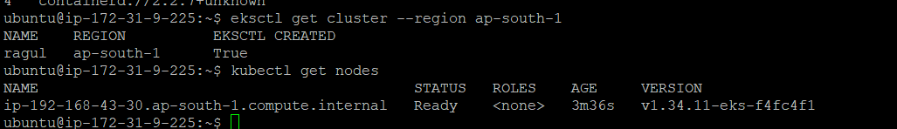
4.Installing Nginx in the server:
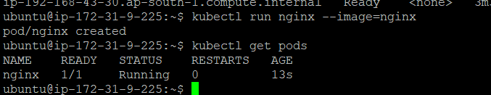
5.Exposing the application with load balancer:
